
Attendance hardware
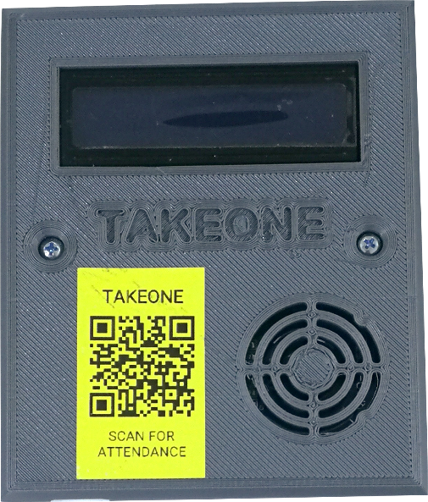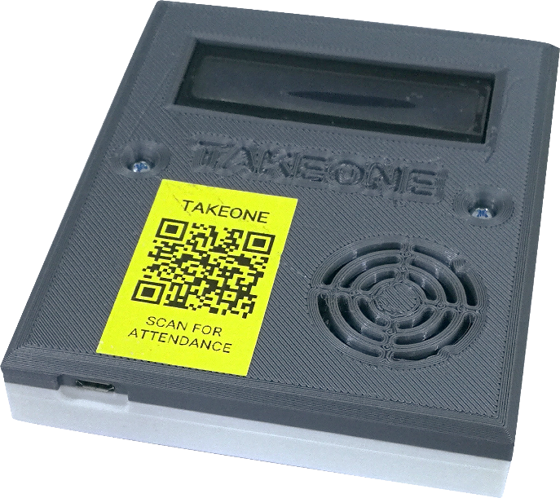
Wi-Fi Based RFID Card Reader

May 23, 2019
TAKEONE
http://takeone.tech

HARDWARE
This is the first version of the hardware and it consists of development boards & breakout boards
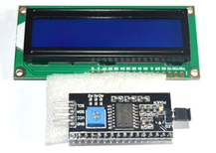 | LCD Display 16x2 Characters  I2C LCD Converter chip
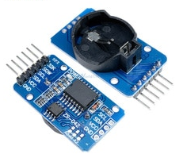 | Real Time Clock Module  With Additional Temperature Sensor
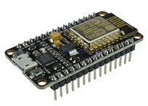 | ESP8266 Development Board  Microcontroller, USB To Serial, Wi-Fi connection
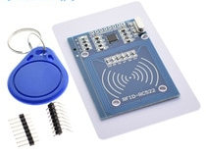 | RFID Module  NFC Compatible Wireless Transceiver Card Reader

Attendance hardware consists
- ESP8266 Dev Board (controller + Wi-Fi)
- Real Time Clock
- NFC/RFID Reader
- LCD Screen
Note:
- ESP32 has quiet good amount of storage, which could be used to store info temporarily with the absence of Wi-Fi connection to a certain limit.
- ESP32 configuration can easily be set via Wi-Fi self-hosted webpage for router or hotspot connection configuration.
The device is operated via a mobile phone charger micro USB connector. That is capable of powering the entire system within with both voltage difference 5V and 3.3V with good amount of current to maintain good operation and avoid device brown out.

HOW DOES IT WORKS
Since we took the matter of security seriously into our design and algorithms, we encourage you to follow the steps of configuration in order to correctly use the hardware for your club.

Register The Device
1st you need to register the device on the platform within your club management dashboard. Then the platform will provide you a device username and a device password.

Device Configuration
Power up your device with micro USB cable. As soon as the device get powered up, it will go into configuration mode and is open to be connectable via Wi-Fi, now using your mobile phone connect to TAKEONE RFID WIFIED network, a configuration webpage will popup, otherwise after connection just go to the web browser like chrome and type the following 192.168.4.1 in the address bar. Select the first chose from the top a blue button that will allow you to view the nearby networks reachable by the device, select you desired network, then put the network password, and the device username, and the device password and press save, the device will store these parameters in its internal memory it may reboot. After a successful connection the LCD should display text as successful connection and displays the IP address on the screen. Then after a short while it will go dark.

Device Operation
When the screen is already dark after powering the device on. Make sure that you assign the card ID to a member of your club. Then try to punch the card by placing it on top the circular engraved are on the device. The device will read the card and authenticate the device along the way, then the device will wait for a response from the server showing the member name and remaining classes to attend other than the current day. As soon as the person reaches close to 3 remaining classes the LCD will blink 3 time indicating that your subscription is about to finish.
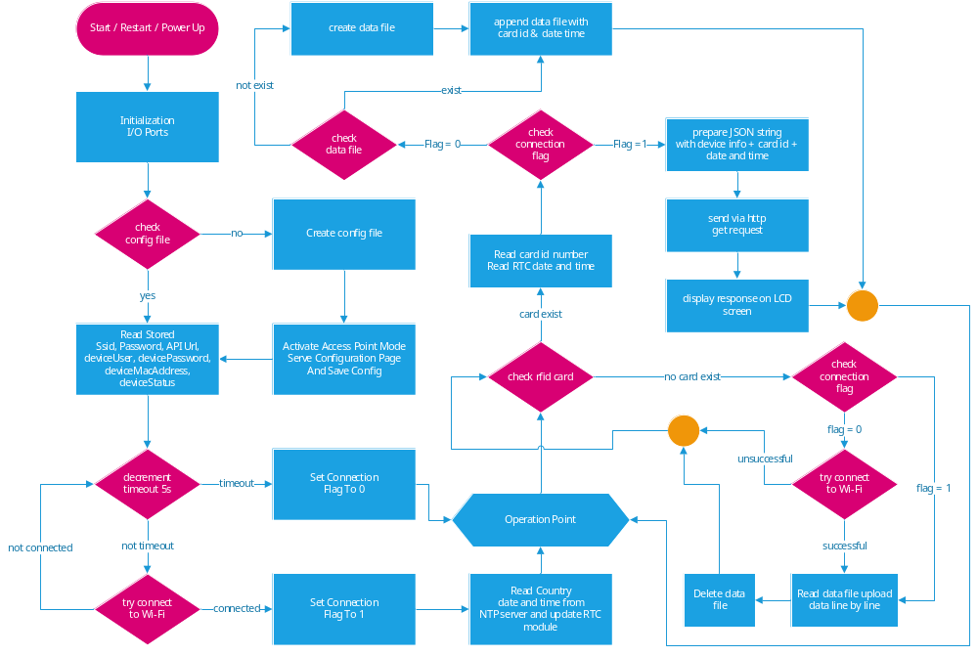

DATA STREAM
The device sends a request to the server, then the server replies with a certain pieces of data, to be displayed on the LCD screen or to do some internal settings or trigger some necessary functionalities or sub routines. The JSON request are listed as the following
- Device Authentication
- Time & Date Auto Correction
- Punching Attendance Card

1st Device Authentication
Once you obtain attendance device unit, the first thing you would do is to configure the Wi-Fi connection and device username and device password. As soon as the device connects to Wi-Fi successfully it will send a JSON request consisting of the following
- Device Username
- Device Password
- Device Mac Address
The response from the server will consists of following parameters
- Request status
- Enable/Disable device punching
- Display message replied from server

2nd Time & Date Auto Correction
The intelligent programming algorithm of device and complete integrity of cloud system enables it auto configure and correct timing based on the country of the club. It will request the correct timing from the NTP server only once to correctly set the RTC module timing to ensure the most effective use of the device. country time zone data from NTP to setup the RTC module.
- Time Update
The response from the server will consist of the following parameter
- Country
- Time Zone
- NTP Date & Time

3rd Punching Attendance Card

