Board Features & Specifications

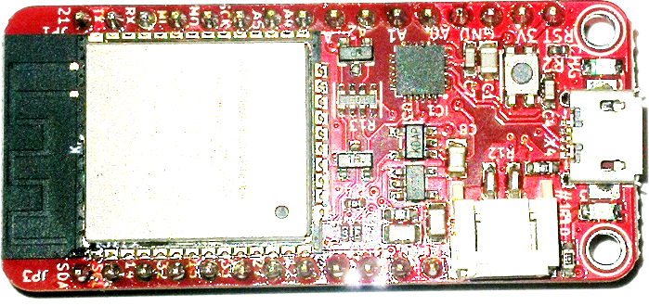 | 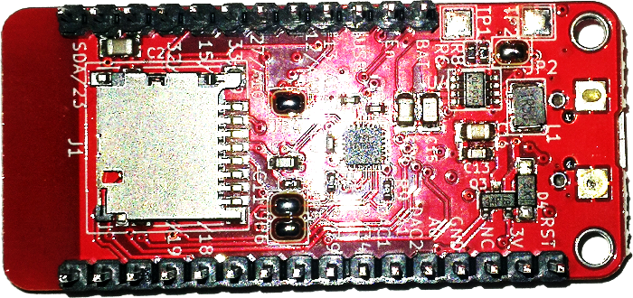
TOP | BOTTOM

- Bluetooth Low Energy & Wi-Fi
- Onboard USB to UART Converter - Via (Serial)
- Onboard Lipoly Battery Management Charging And Protection
- Onboard Lipoly Battery Monitoring - Via Analog Pin GPIO# 35
- Onboard micro SDCARD Reader Slot - Via SPI GPIO# (CS 5, SCK 18, MISO 19, MOSI 23)
- Onboard Voltage Booster (3.3 Volts to 5 Volts) - Via GPIO# 14 (HIGH ON / LOW OFF)
- Onboard IMU 9 Degrees of Freedom MPU9250 (0X69) - Via I2C GPIO# (SDA 21, SCL 22)
- 240 MHz dual core Ten silica LX6 microcontroller with 600 DMIPS
- Integrated 520 KB SRAM
- Integrated 802.11b/g/n HT40 Wi-Fi transceiver, baseband, stack and LWIP
- 4 Mega Byte Flash
- On-board PCB antenna
- Ultra-low noise analog amplifier
- Hall Sensor
- 10x capacitive touch interface
- 32 kHz crystal oscillator
- 12 x ADC input channels
- 2 x I2S Audio
- 2 x DAC
- PWM/timer input/output available on every GPIO pin
- OpenOCD debug interface with 32 kB TRAX buffer
- SDIO master/slave 50 MHz

Pinouts
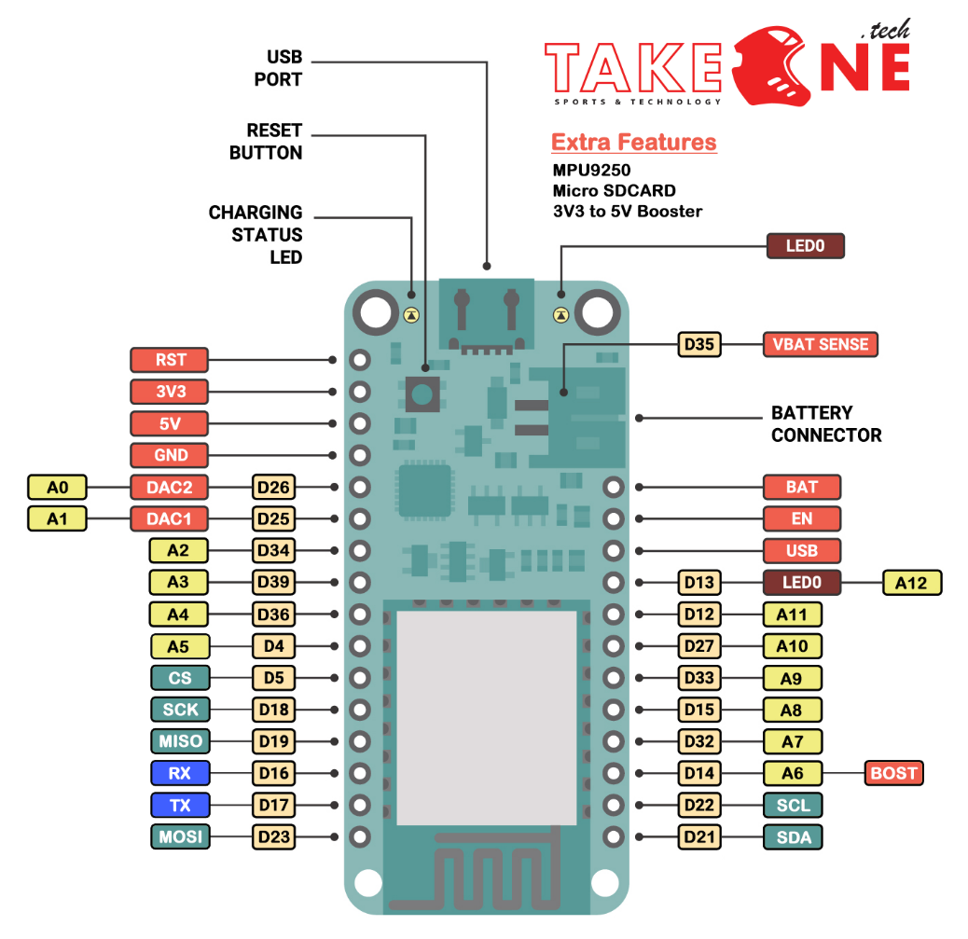

GPIO & Analog Pins
There are tons of GPIO and analog inputs available to you for connecting LEDs, buttons, switches, sensors, etc. Here's the remaining pins available.

Short Pin Header
- A0 - this is an analog input A0 and also an analog output DAC2. It can also be used as a GPIO #26
- A1 - this is an analog input A1 and also an analog output DAC1. It can also be used as a GPIO #25
- A2 - this is an analog input A2 and also GPI #34. Note it is not an output-capable pin!
- A3 - this is an analog input A3 and also GPI #39. Note it is not an output-capable pin!
- A4 - this is an analog input A4 and also GPIO #36
- A5 - this is an analog input A5 and also GPIO #4
- 21 - General purpose IO pin #21

Long Pin Header
- 13 - This is GPIO #13 and also an analog input A12. It's also connected to the red LED next to the USB port It’s also connected to the red LED next to the USB port
- 12 - This is GPIO #12 and also an analog input A11. This pin has a pull-down resistor built into it, we recommend using it as an output only, or making sure that the pull-down is not affected during boot.
- 27 - This is GPIO #27 and also an analog input A10
- 33 - This is GPIO #33 and also an analog input A9. It can also be used to connect a 32 KHz crystal.
- 15 - This is GPIO #15 and also an analog input A8
- 32 - This is GPIO #32 and also an analog input A7. It can also be used to connect a 32 KHz crystal.
- 14 - This is GPIO #15 and also an analog input A6
- SD-card interface support

Power Pins
- GND - this is the common ground for all power and logic
- BAT - this is the positive voltage to/from the JST jack for the optional Lipoly Battery
- USB - this is the positive voltage to/from the micro USB jack if connected
- EN - this is the 3.3V regulator's enable pin. It's pulled up, so connect to ground to disable the 3.3V regulator
- 3V - this is the output from the 3.3V regulator. The regulator can supply 500mA peak but half of that is drawn by the ESP32, and it's a fairly power-hungry chip. So if you need a ton of power for stuff like LEDs, motors, etc. Use the USB or BAT pins, and an additional regulator
- 5V – this is the output from the booster circuit, 5 Volts only when the booster is enabled

Serial Pins
RX and TX are the additional Serial2 pins, and are not connected to the USB/Serial converter. That means you can use them to connect to UART-devices like GPS's, fingerprint sensors, etc. The TX pin (D17) is the output from the module. The RX pin (D16) is the input into the module. Both are 3.3V logic

I2C & SPI Pins
You can use the ESP32 to control I2C and SPI devices, sensors, outputs, etc. If using with Arduino, the standard Wire and SPI devices work as you'd expect!
Note that the I2C pins do not have pull up resistors already! You must add them if you want to communicate with an I2C device

Useful Links
Here you will find useful links, which you might need while working using our esp32 board.

USB to UART Driver
- https://www.silabs.com/products/development-tools/software/usb-to-uart-bridge-vcp-drivers

ESPRESSIF Overview
- https://espressif.com/en/products/hardware/esp32/overview

