Introduction
The kicker is a project for collecting data from every member registered on TAKEONE platform. The data that is being collected is through a hardware enabled device. In order to do that, this process needs to be done on stages
- The mobile app has to connect to TAKEONE platform and get the data of the member
- The mobile app has to connect to TAKEONE Kicker Hardware via Bluetooth
- The user selects a game of choice
  - Counter
  - Time Attack
  - Reaction Meter
  - Decision Meter
  - Stamina Meter
- At the end of the game the results are being uploaded to TAKEONE platform via the mobile phone.
- The collected data should be displayed on TAKEONE App & Platform as latest performance Chart.
Our last investor requested to see this working in action. In order secure the investment. Let’s do this and get the money to explode to market.

Hardware Construction Of The Kicker
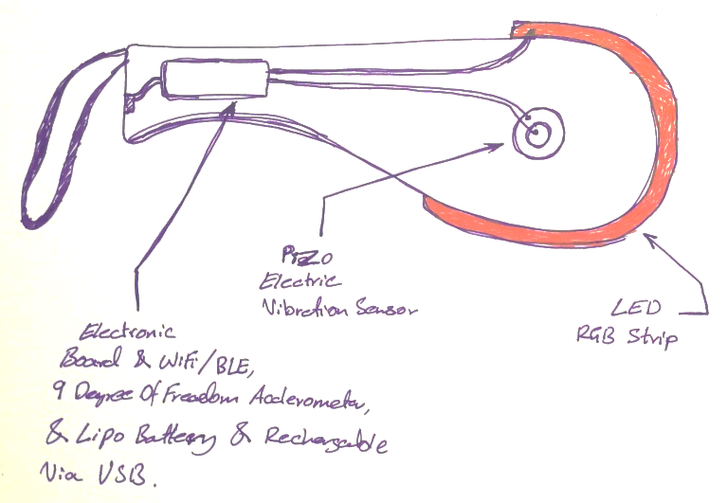 | 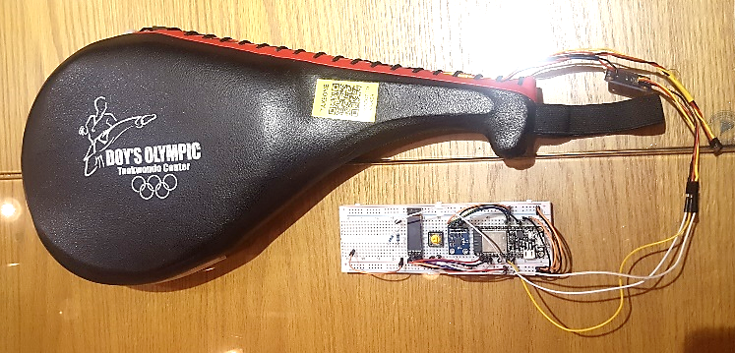
The kicker hardware is a combination of modules
- RGB Addressable RGB LED Light Strip
- Piezo Electric Vibration Sensor
- Electronic Board
  - uController : ESP32 WROOM with wireless Wi-Fi & Bluetooth Capability
  - Nine Degree of Freedom Accelerometer MPU9250
  - Buck boost Converter 3.7 to 5 Volts Converter
  - Single Cell Lithium Ion battery charger manager
  - Micro USB port for programming debugging and charging

1st Stage: Connecting to platform
The user opens the TAKEONE app and put his credentials and submit them by pressing login button. These credentials then have to be sent from mobile app to an API on TAKEONE platform that receives authentication requests and reply’s back to the app in case of successful authentication with the data displayed
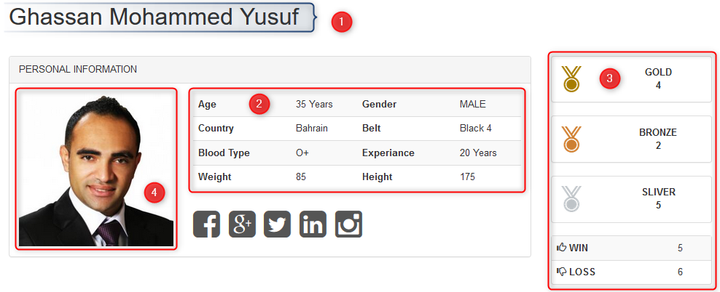
Along with the unique ID code of the member because it’s the only identifier of the member’s data. In case we need to upload data to the profile later.

2nd Stage: Connecting to Hardware
After user successful login process and data being received to the mobile app and being displayed. The user must connect to a hardware device via Bluetooth.

3rd Stage: Selecting a game to play
After connecting to TAKEONE KICKER. Then the user should select a game with default settings or custom settings. The app should prepare a JSON format of the game and its setting combined then send it to TAKEONE KICKER via Bluetooth and then the kicker will start the game, while playing the game the TAKEONE KICKER will send data to be displayed and collected in the application in JSON format.

4th Stage: Uploading the game result
At the end of the game the JSON format message should have the following information.
- Member Unique ID
- Game Name
- Game Settings
- Game Data (Collected)
- Game Results
- Date & Time (Timestamp)
Then this JSON data is to be sent to TAKEONE platform database as a record.

5th Stage: Display latest game data on platform & mobile app
After the data being inserted successfully in to the database, when a member loges in or refreshes his page the latest game data should be displayed as a time graph using Chart JS the user should be able to display not only current game graph line but also can select a game result in his history to see how different he performed. Below is an example
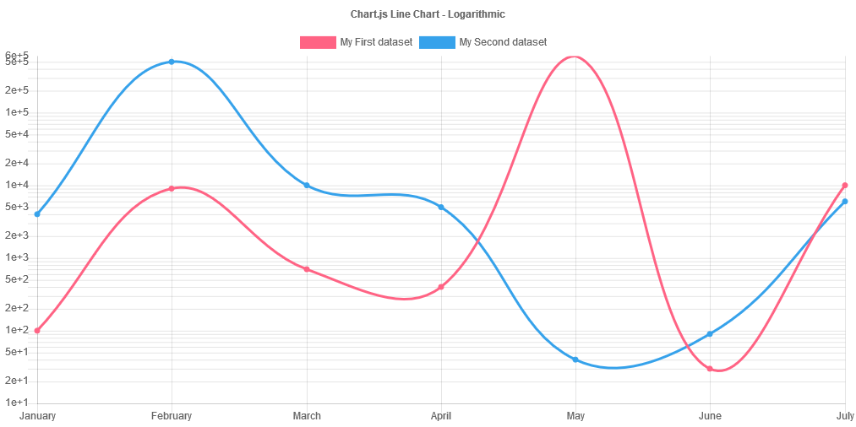
The only difference that instead of months it’s going to be the y axis the reaction time in milliseconds and the x axis is the trials count. So the person can also display a specific game data from history to compare performances. Like blue line is the latest data and the red line is the select history performance data.

